AI Assisted Coding

Name:M.Sanjay
HT.no:2303A54036
Assignment: 7.1 Task1:
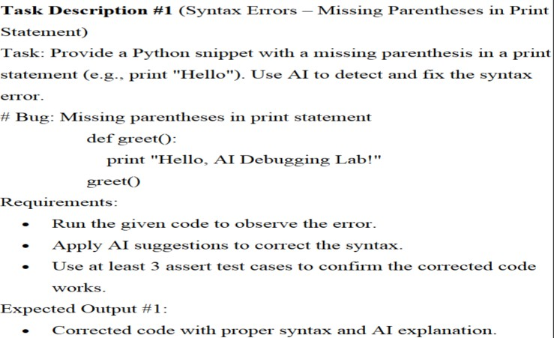
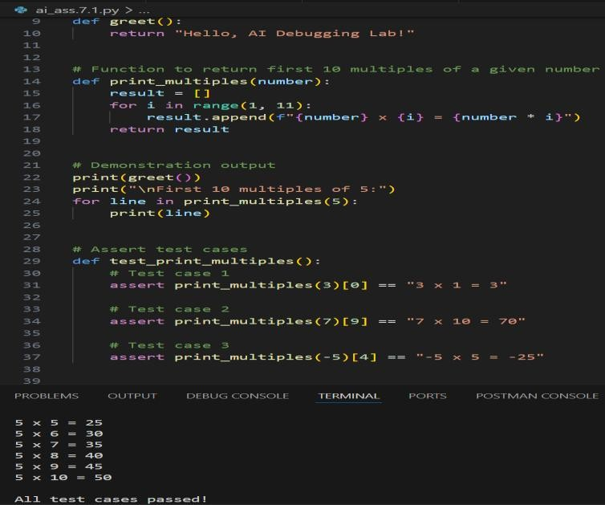
Ai generated code:

#Create a simple Python program that contains a syntax error caused by missing
parentheses in a print statement. Run the code to observe the error, then use AI
assistance to identify and fix the syntax issue. After correcting the code, add
at least three assert test cases to verify that the function works correctly.
Keep the explanation clear and beginner-friendly, and ensure the final program
runs without errors.
Task2:
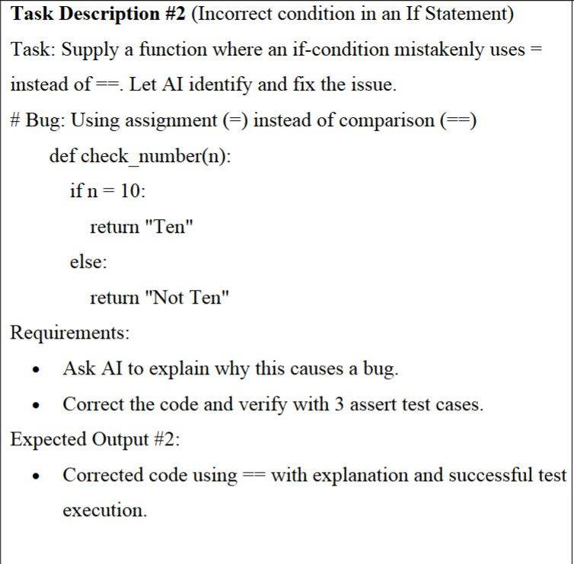
Ai generated code:
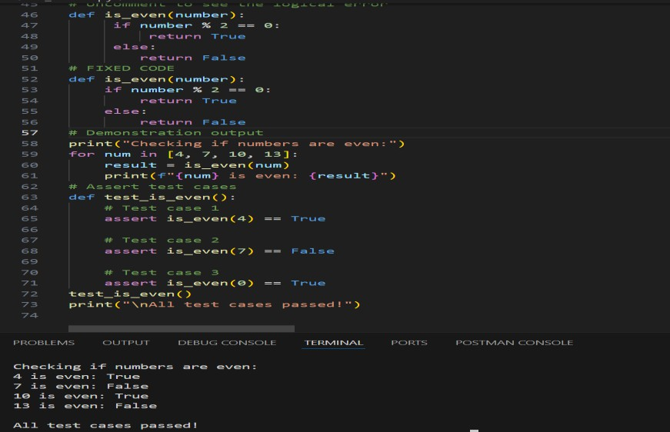

#Create a simple Python function that contains a bug where an if condition
incorrectly uses the assignment operator (=) instead of the comparison operator
(==). Run the code to observe the error, then use AI assistance to identify and
explain why this causes a bug. Correct the condition using == and verify the fix
by adding at least three assert test cases. Keep the code and explanation clear,
beginner-friendly, and ensure the final program runs without errors
Task3:
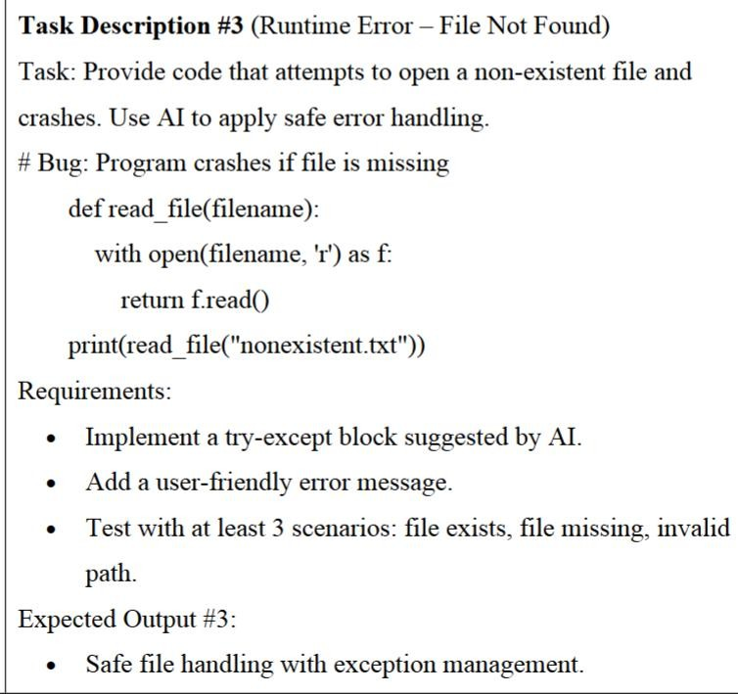
Ai generated code:
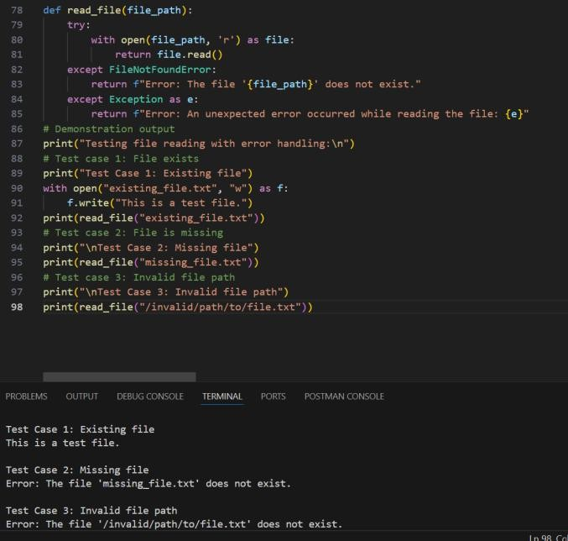

#Create a Python program that attempts to open a file that does not exist,
causing a runtime error. Run the program to observe the crash, then use AI
assistance to apply safe error handling using a try-except block. Modify the code
to display a clear, user-friendly error message instead of crashing. Finally,
test the corrected program with at least three scenarios: when the file exists,
when the file is missing, and when an invalid file path is provided. Ensure the
final code runs safely without errors
Task4:
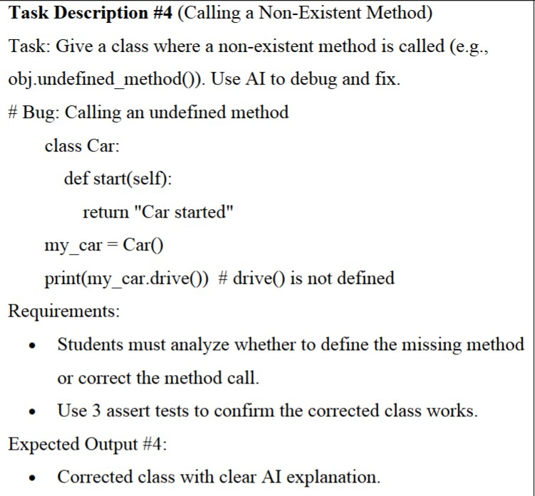
Ai generated code:
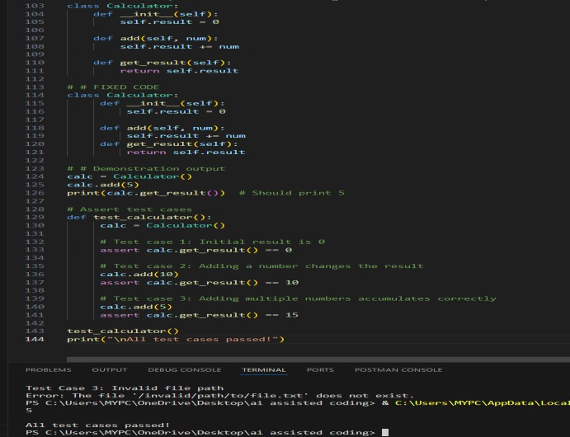

#Create a simple Python program to calculate the sum of the first n natural
numbers. First, write a function named sum_to_n(n) that uses a for loop to
compute the sum. Then, implement an alternative solution using a while loop or a
mathematical formula. Display the result for sample inputs and keep the code
clear, beginner-friendly, and easy to understand. Ensure the program runs without
errors and clearly shows the output

Tack5:
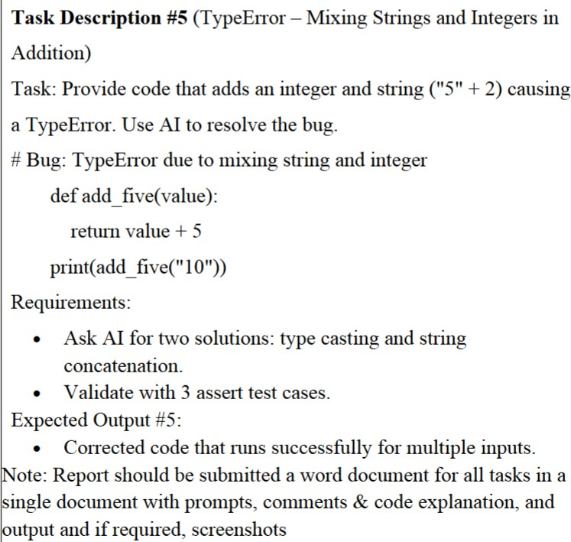
Ai generated code:
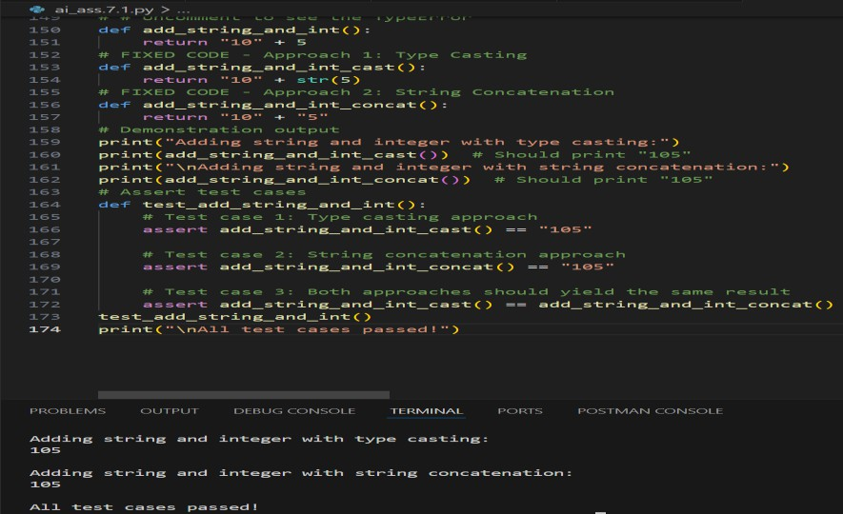

Prompt:

#Create a simple Python program that causes a TypeError by trying to add a string
and an integer (for example, "10" + 5). Run the code to observe the error, then
use AI assistance to identify and explain why the error occurs. Fix the problem
using two different approaches: first by applying type casting, and second by
using string concatenation. Verify both solutions by adding at least three assert
test cases. Keep the code clear, beginner-friendly, and ensure the final program
runs successfully for multiple inputs.

